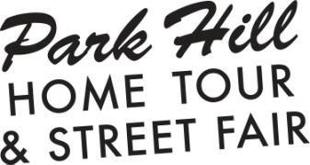

Tear-Down Crew Volunteers

Brief overview of your role:
The tear-down crew will help break down tents, signage, tables and chairs, and carry unused cases of wine, beer and/or bags of ice for transport. Tear-down crew volunteers should be in good health and be prepared for physical work and lifting. Thank you for volunteering!

Schedule overview:
Friday | 6:00 PM - 8:00 PM | Volunteer and Sponsor Appreciation Party (Long Table Brewhouse 2895 Fairfax St.)
Sunday | 8:00AM – 11:00AM | Street Fair setup
Sunday | 11:00 AM - 5:00 PM | Park Hill Home Tour & Street Fair
Sunday | 5:00PM – 7:00PM | Street Fair tear-down

You have signed up to help with our TEAR-DOWN CREW. The time for this shift is 5:00 PM – 7:00 PM. At the beginning of your shift, please report to the GPHC information booth at Montview and Forest Parkway to get a name tag and then proceed to the intersection of 19th and Forest Parkway for instructions. Please arrive no later than 5 p.m.

The Park Hill Home Tour and Street Fair runs from 11:00AM – 5:00PM. You may participate in the home tour by wearing your volunteer name tag for access. Visit the GPHC info booth at any time to retrieve ^{your} ^{name} ^{tag.} www.parkhillhometour.org

